SQL Project

Name of the project:

**ScienceQtech Employee Performance Mapping.**

**Done by:**Mrinmay Saha

DESCRIPTION

ScienceQtech is a startup that works in the Data Science field. ScienceQtech has worked on fraud detection, market basket, self-driving cars, supply chain, algorithmic early detection of lung cancer, customer sentiment, and the drug discovery field. With the annual appraisal cycle around the corner, the HR department has asked you (Junior Database Administrator) to generate reports on employee details, their performance, and on the project that the employees have undertaken, to analyze the employee database and extract specific data based on different requirements.

**Objective:**

To facilitate a better understanding, managers have provided ratings for each employee which will help the HR department to finalize the employee performance mapping. As a DBA, you should find the maximum salary of the employees and ensure that all jobs are meeting the organization's profile standard. You also need to calculate bonuses to find extra cost for expenses. This will raise the overall performance of the organization by ensuring that all required employees receive training.

**Note:** You must download the dataset from the course resource section in LMS and create a table to perform the above objective.

**Dataset description:**

**emp_record_table:** It contains the information of all the employees.

* EMP_ID – ID of the employee
* FIRST_NAME – First name of the employee
* LAST_NAME – Last name of the employee
* GENDER – Gender of the employee
* ROLE – Post of the employee
* DEPT – Field of the employee
* EXP – Years of experience the employee has
* COUNTRY – Country in which the employee is presently living
* CONTINENT – Continent in which the country is
* SALARY – Salary of the employee
* EMP_RATING – Performance rating of the employee
* MANAGER_ID – The manager under which the employee is assigned
* PROJ_ID – The project on which the employee is working or has worked on

**Proj_table:**It contains information about the projects.

* PROJECT_ID – ID for the project
* PROJ_Name – Name of the project
* DOMAIN – Field of the project
* START_DATE – Day the project began
* CLOSURE_DATE – Day the project was or will be completed
* DEV_QTR – Quarter in which the project was scheduled
* STATUS – Status of the project currently

**Data_science_team:** It contains information about all the employees in the Data Science team.

* EMP_ID – ID of the employee
* FIRST_NAME – First name of the employee
* LAST_NAME – Last name of the employee
* GENDER – Gender of the employee
* ROLE – Post of the employee
* DEPT – Field of the employee
* EXP – Years of experience the employee has
* COUNTRY – Country in which the employee is presently living
* CONTINENT – Continent in which the country is

**Source Code with output:**

/*Create a database named employee, then import data_science_team.csv proj_table.csv and emp_record_table.csv

into the employee database from the given resources.*/

create database employee;

use employee;

select * from data_science_team;

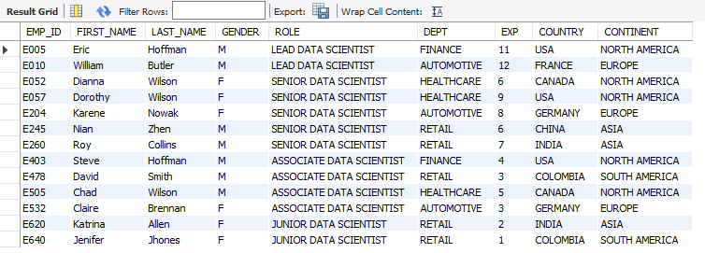

select * from emp_record_table;

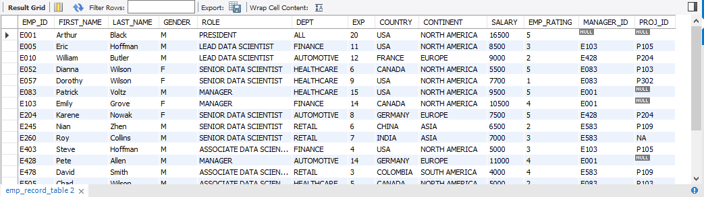

select * from proj_table;

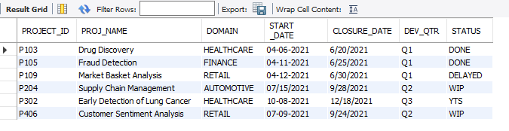

/*Write a query to fetch EMP_ID, FIRST_NAME, LAST_NAME, GENDER, and DEPARTMENT from the employee record table,

and make a list of employees and details of their department.*/

select emp_id,first_name,last_name,gender,dept from emp_record_table order by first_name;

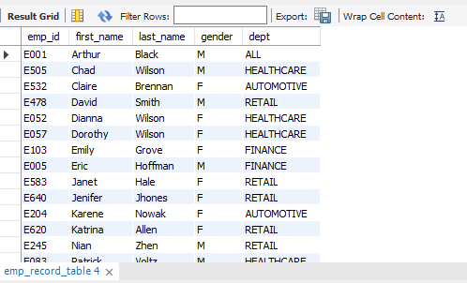

/*Write a query to fetch EMP_ID, FIRST_NAME, LAST_NAME, GENDER, DEPARTMENT, and EMP_RATING if the EMP_RATING is:

less than two

greater than four

between two and four*/

select emp_id,first_name,last_name,gender,dept,emp_rating from emp_record_table where emp_rating<2;

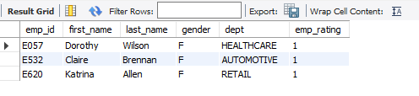

select emp_id,first_name,last_name,gender,dept,emp_rating from emp_record_table where emp_rating>4;

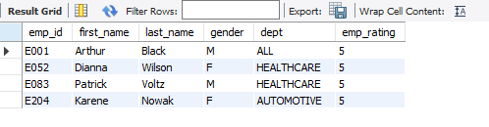

select emp_id,first_name,last_name,gender,dept,emp_rating from emp_record_table where emp_rating between 2 and 4;

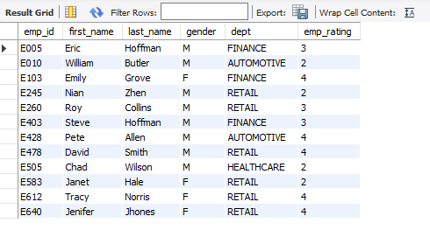

/*Write a query to concatenate the FIRST_NAME and the LAST_NAME of employees in the

Finance department from the employee table and then give the resultant column alias as NAME.*/

select concat(first_name,' ',last_name) as Name from emp_record_table where dept='Finance';

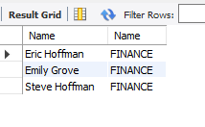

/*Write a query to list only those employees who have someone reporting to them.

Also, show the number of reporters (including the President).*/

select manager_id,first_name,last_name,role,count(emp_id) as emp_count

from emp_record_table group by manager_id order by manager_id;

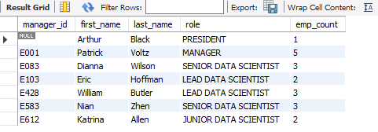

/*Write a query to list down all the employees from the healthcare and finance departments using union.

Take data from the employee record table.*/

select emp_id,first_name,last_name,gender,dept from emp_record_table where dept='healthcare'

union

select emp_id,first_name,last_name,gender,dept from emp_record_table where dept='finance';

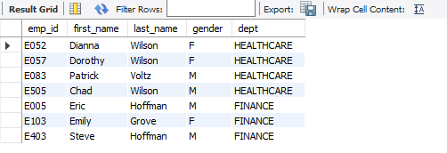

/*Write a query to list down employee details such as EMP_ID, FIRST_NAME, LAST_NAME, ROLE, DEPARTMENT,and EMP_RATING grouped by dept.

Also include the respective employee rating along with the max emp rating for the department.*/

select emp_id,first_name,last_name,role,dept,emp_rating,max(emp_rating) from emp_record_table group by dept;

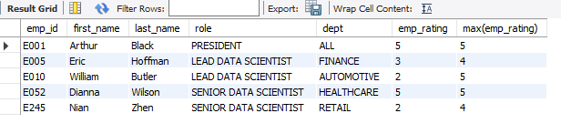

/*Write a query to calculate the minimum and the maximum salary of the employees in each role.

Take data from the employee record table.*/

select emp_id,first_name,last_name,role,

max(salary) as Max_salary,min(salary) as min_salary

from emp_record_table group by role;

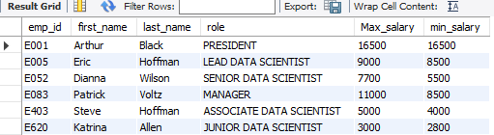

/*Write a query to assign ranks to each employee based on their experience.

Take data from the employee record table.*/

select emp_id,first_name,last_name,exp,rank() over(order by exp desc) as Rank_exp from emp_record_table;

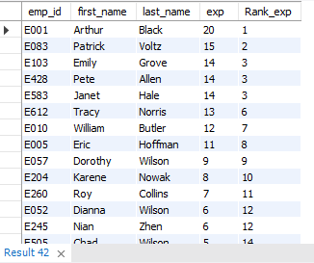

/*Write a query to create a view that displays employees in various countries whose salary is more than six thousand.

Take data from the employee record table.*/

create view emp_sal as

select emp_id,first_name,last_name,country,salary from emp_record_table

where salary> 6000 group by country order by salary;

select * from emp_sal;

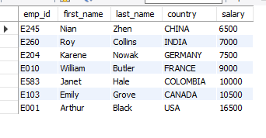

/*Write a nested query to find employees with experience of more than ten years.

Take data from the employee record table.*/

select * from emp_record_table where exp in

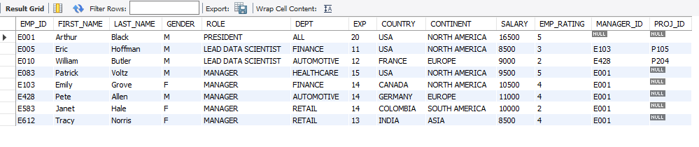(select exp from emp_record_table where exp> 10);

/*Write a query to create a stored procedure to retrieve the details of the

employees whose experience is more than three years.

Take data from the employee record table.*/

delimiter \

create procedure emp_exp()

begin

select * from emp_record_table where exp>10 order by exp desc;

end \

call emp_exp();

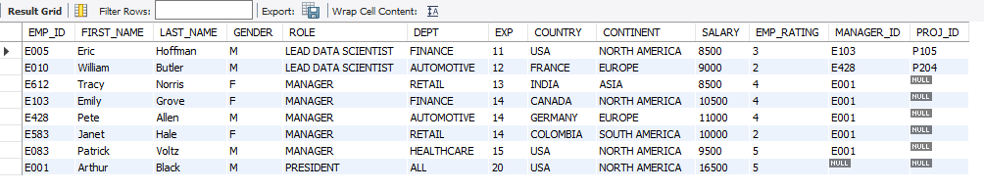

/*Create an index to improve the cost and performance of the query to find the

employee whose FIRST_NAME is ‘Eric’ in the employee table after checking the execution plan.*/

create index indx on emp_record_table(role);

explain select * from emp_record_table WHERE first_name = 'Eric';



/*Write a query to calculate the bonus for all the employees,

based on their ratings and salaries (Use the formula: 5% of salary * employee rating).*/

select emp_id,salary,emp_rating,((salary*5/100)*emp_rating) as bonus FROM emp_record_table;

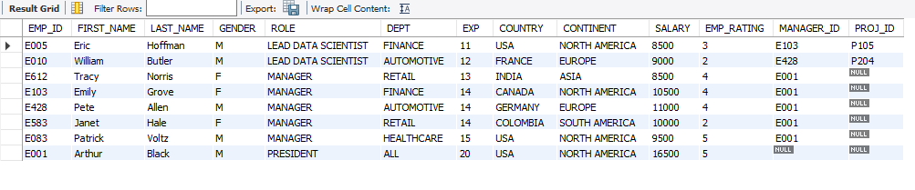

/*Write a query to calculate the average salary distribution based on the continent and country. \

Take data from the employee record table.*/

SELECT continent, avg(Salary) FROM emp_record_table group by continent;

SELECT country, avg(Salary) FROM emp_record_table group by country;

select continent,

(select avg(b.Salary) from emp_record_table b where a.continent = b.continent) as continentAvg,

country,

(select avg(c.Salary) from emp_record_table c where a.country = c.country) as countryAvg

FROM emp_record_table a

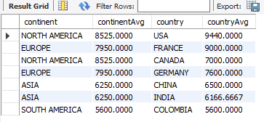group by continent,country;